DESIGN TABLES FOR PRODUCT AND CATEGORY ENTITIES.
Project Title: Order Management System

Project Title : Order Management System
Student Name : Tamil raj M
Register Number : C4S38022
Department : B.Sc Artificial Intelligence
Course : Artificial intelligence (AI)
Academic Year : 2024 – 2027

1. Create Tables
CREATE DATABASE OrderDB;
USE OrderDB;

CREATE TABLE Orders (
OrderID INT PRIMARY KEY,
CustomerName VARCHAR(50),
OrderDate DATE,
TotalAmount INT
);

CREATE TABLE Order_Details (
DetailID INT PRIMARY KEY,
OrderID INT,
ProductName VARCHAR(50),
Quantity INT,
Price INT,
FOREIGN KEY (OrderID) REFERENCES Orders(OrderID)
);
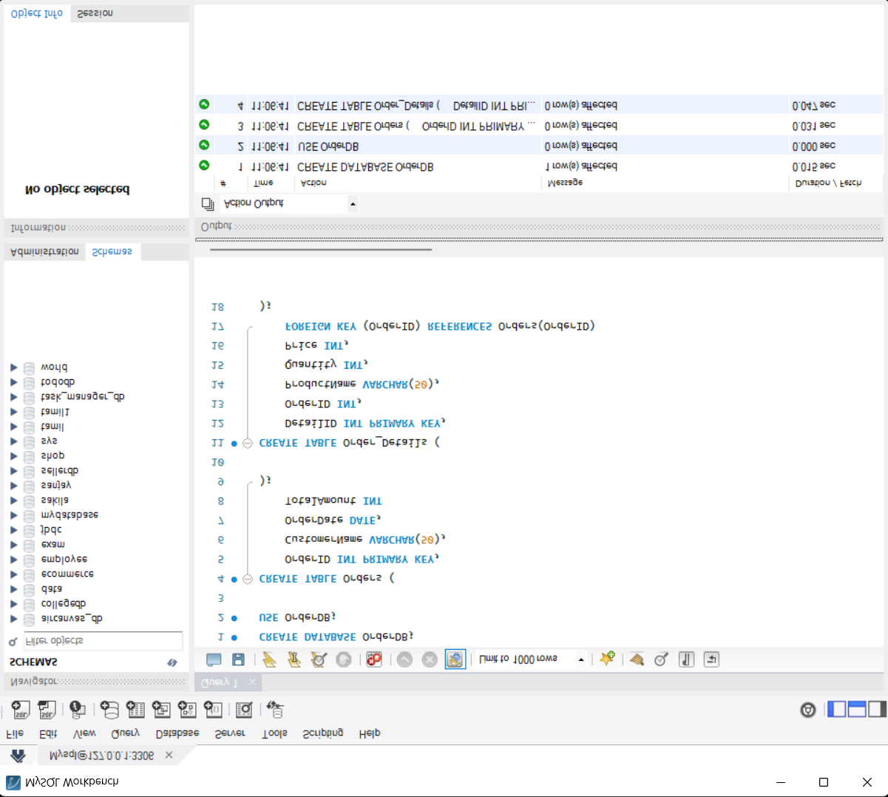

2. Insert Orders
INSERT INTO Orders VALUES
(1, 'Ravi', '2026-08-01', 5000),
(2, 'Kumar', '2026-08-02', 3000),
(3, 'Arun', '2026-08-03', 7000);
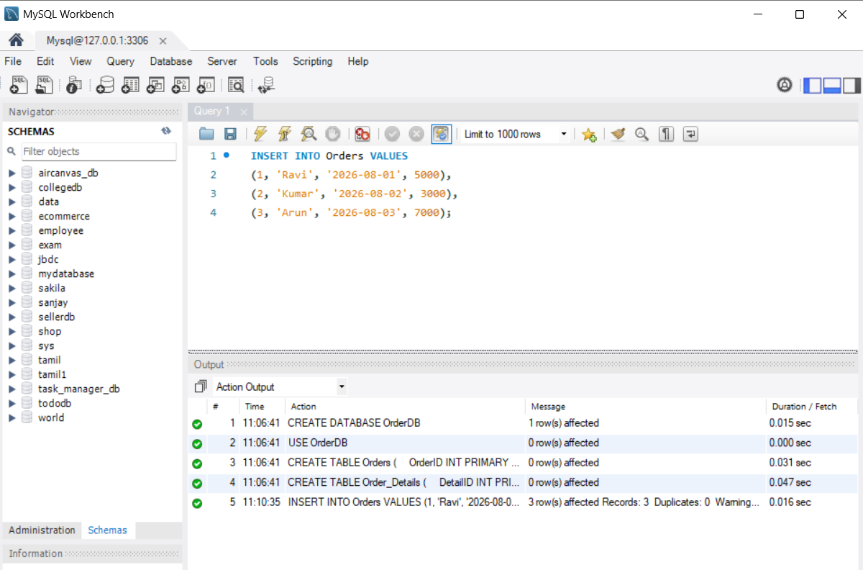

3. Insert Order Details
INSERT INTO Order_Details VALUES
(101, 1, 'Laptop', 1, 5000),
(102, 2, 'Mobile', 1, 3000),
(103, 3, 'Headphone', 2, 3500);

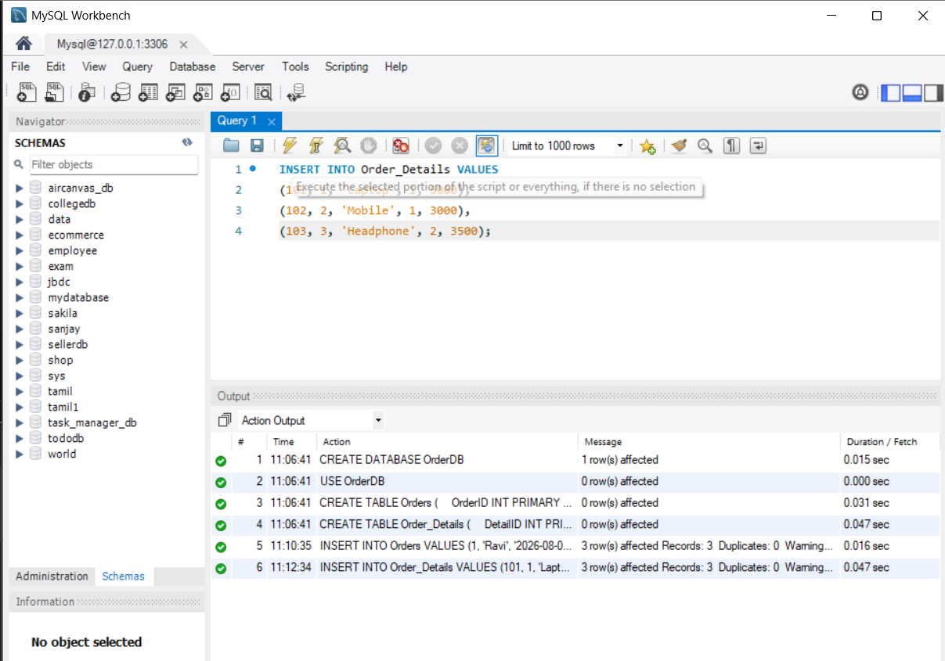

4. Display Orders
SELECT * FROM Orders;

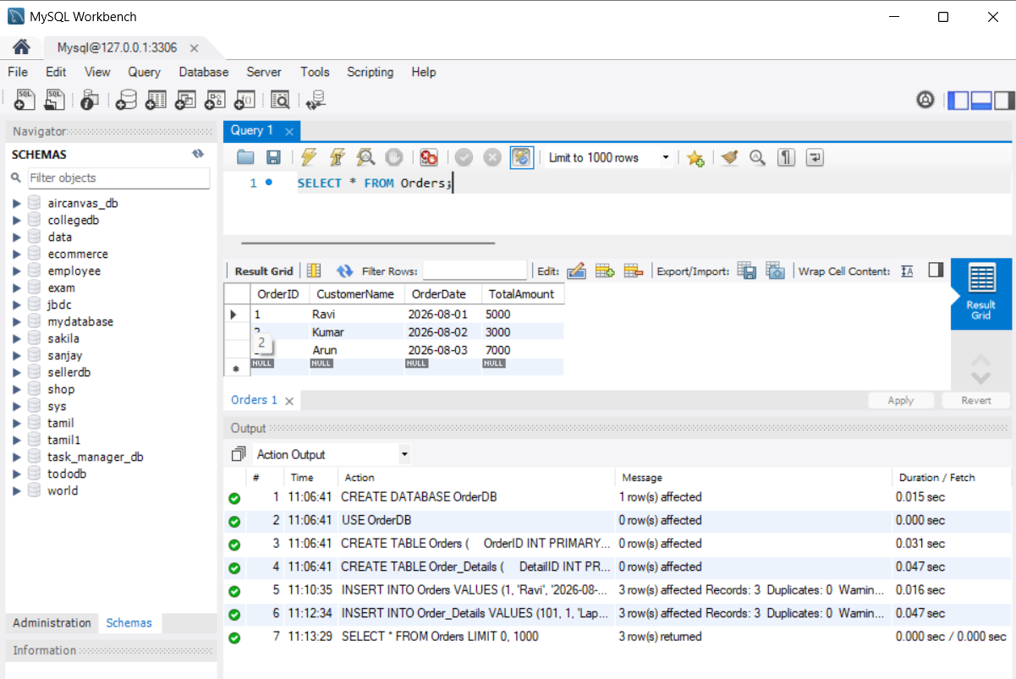

5. Update Order
UPDATE Orders
SET TotalAmount = 5500
WHERE OrderID = 1;

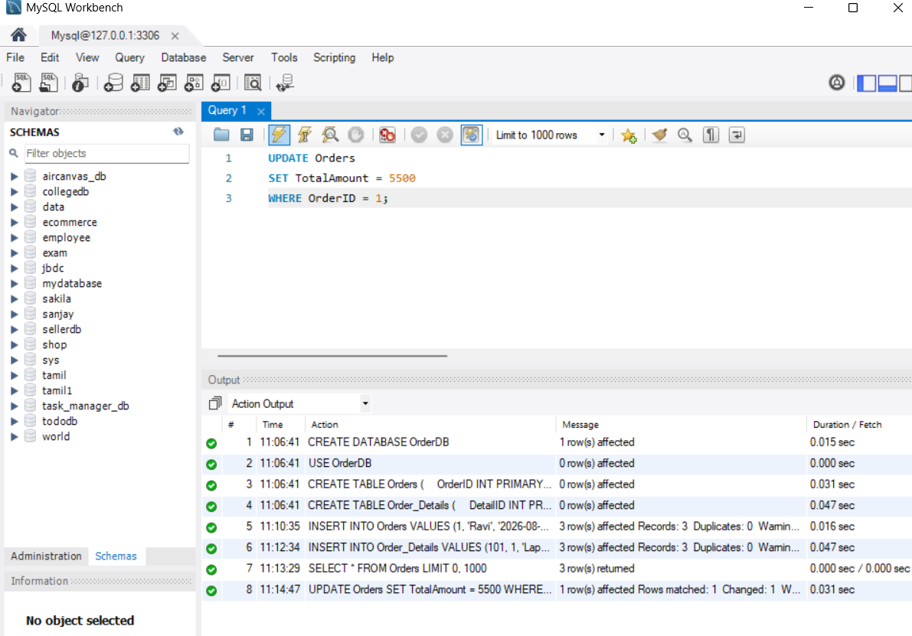

6. Customer Order History
SELECT
Orders.CustomerName,
Orders.OrderDate,
Order_Details.ProductName,
Order_Details.Quantity,
Orders.TotalAmount
FROM Orders
JOIN Order_Details
ON Orders.OrderID = Order_Details.OrderID
ORDER BY Orders.OrderDate;

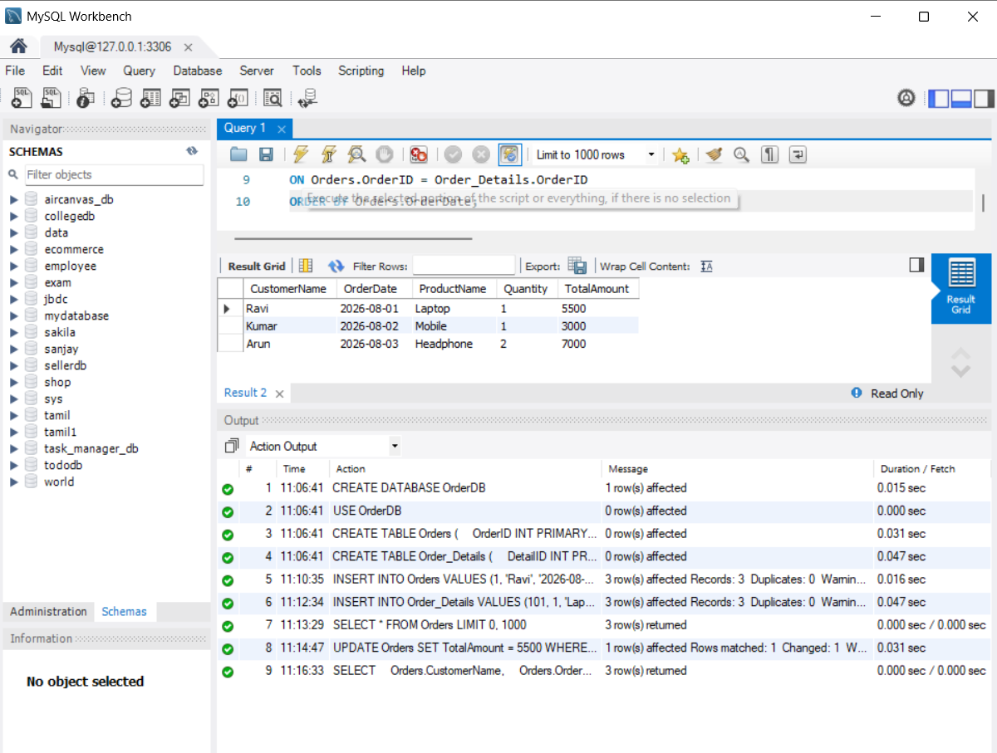

7. Customer-wise Order Report
SELECT CustomerName, COUNT(OrderID) AS TotalOrders
FROM Orders
GROUP BY CustomerName;

